EduGenie: Google Gemini Powered Learning Assistant
Asan Memorial Collage of Arts & Science
Department of 2nd B.Sc Computer Science

Project Team
- Vigneshwaran R – NM ID:
79EF3DC9787F50FA77A4355437B83AEF

Team Members

- Bharani O – NM ID:
78F48DAC8E511CC80874EE2ACEFBBF0B

- Mahalingam K – NM ID:
0EA0350F0442DC9BA4E49A3074DC5617

- Sanjay S – NM ID:
9B45A2F13C6DAC984A3478AD9747F241

Project Description
EduGenie is a lightweight AI-powered educational assistant that simplifies learning through generative AI. Designed for students of all academic levels, EduGenie enables users to:
- Ask questions and receive smart, concise answers
- Understand complex concepts through simplified explanations
- Generate quizzes from topics or text
- Receive personalized learning recommendations
- Summarize large educational passages
Built with FastAPI for the backend and a simple HTML+CSS frontend, EduGenie leverages lightweight and cloud-based AI models for local efficiency and cloud power. It works well on devices like the Mac M1, making it accessible to a broad range of learners and developers.
Scenarios
Scenario 1: A student wants to know about oceans and rivers uses EduGenie to ask “Which is the largest ocean?”
Scenario 2: A student wants to know the level of her understanding of “The Pythagoras Theorem” and clicks “Generate Quiz.”
Scenario 3: A learner exploring SQL requests a learning path which is a structured plan with beginner to advanced topics, timelines, and suggestions.

ARCHITECTURAL DIAGRAM
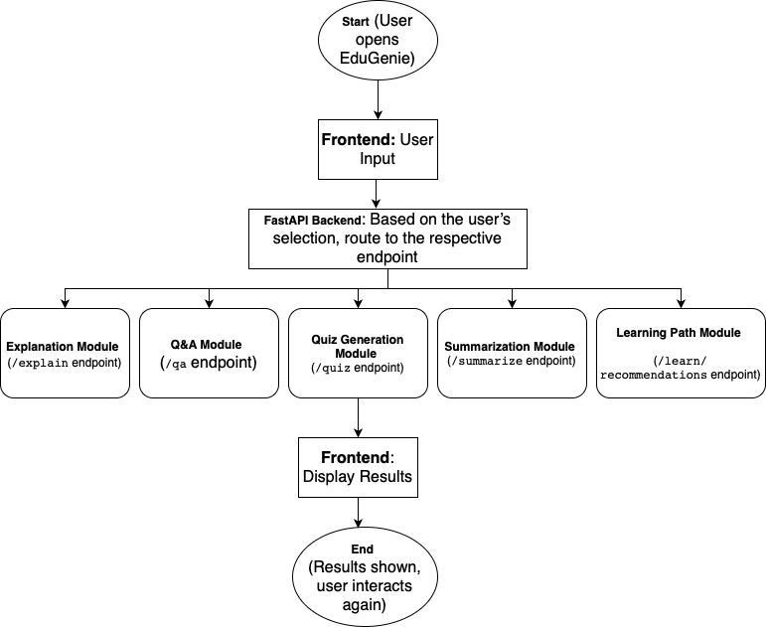

Pre-requisites

Python 3.10+
- Official Documentation: Google AI for Developers
- Installation Guide: Tom's Hardware
- Popular Tutorial: Python Programming Tutorial - Full Course for Beginners
- Installation Steps:
- Download the latest Python 3.10+ installer for your operating system from the official website.
- Run the installer and ensure you check the box that says "Add Python to PATH".
- Follow the installation prompts to complete the setup.
- Verify the installation by opening a terminal or command prompt and typing python --version.

- FastAPI Framework –
- Official Documentation: FastAPI
- User Guide: FastAPI
- Popular Tutorial: FastAPI Crash Course
- HTML & CSS – Basic templating used in /templates and /static

Google Gemini API Key
- Official Documentation: Google AI for Developers
- Setup Guide: GeeksforGeeks
- Popular Tutorial: How to Use Google Gemini API Key
- Setup Steps:
  - Visit the Google AI Studio and sign in with your Google account.
  - Create a new project and enable the Gemini API.
  - Generate an API key and securely store it.

Uvicorn (ASGI Server)
- Official Documentation: PyPI
- Installation Steps:
  - Install Uvicorn using pip: pip install uvicorn

Jinja2 (HTML Templating Engine)
- Official Documentation: Jinja2 Documentation
- Installation Steps:
  - Install Jinja2 using pip: pip install jinja2

Project Workflow
MILESTONE 1: Model Selection and Architecture
Activity 1.1: Select AI Models
- Gemini 1.5 Pro (via API):
Used for: Q&A, summarization, quiz generation, learning paths
Benefits: Advanced reasoning, structured outputs, and cloud inference
- LaMini-Flan-T5-783M (local):
Used for: Concept explanation
Benefits: Instruction-tuned, lightweight, CPU-compatible
Folder Architecture:
EduGenie/
- main.py # FastAPI app
- explanation_module.py # Concept explanation logic
- qna.py # Question answering
- quiz_module.py # Quiz generation
- summary_module.py # Summarization
- learning_path.py # Learning recommendations
- templates/index.html # HTML frontend
- static/style.css # Styling
- requirements.txt # Python dependencies

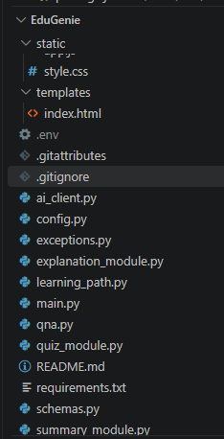

FIG. Showing the Folder Architecture
MILESTONE 2: Core Functionalities Development
Activity 2.1. : Module Implementation
- Explanation Module
EduGenie utilizes the LaMini-Flan-T5 model, a lightweight yet powerful generative AI, to deliver educational content in a simplified and highly readable manner. This model is specifically fine-tuned to provide concise, context-aware responses that break down complex topics into easily understandable language. By focusing on clarity and brevity, EduGenie ensures that learners with minimal background knowledge or technical experience can grasp essential concepts without feeling overwhelmed. This makes it particularly valuable for beginners, school students, or self-learners seeking straightforward explanations. The integration of LaMini-Flan-T5 empowers EduGenie to act as a reliable and accessible study companion for foundational learning across subjects.
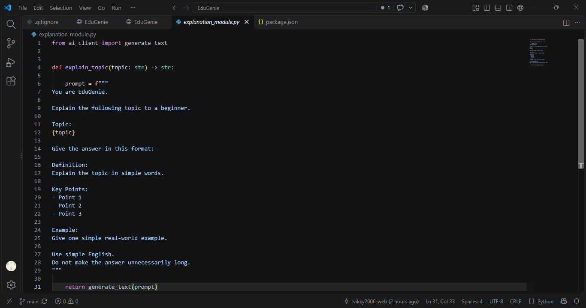

Fig. Explanation module logic
- QnA Module
EduGenie is powered by Gemini 1.5 Pro, enabling it to handle a wide range of general knowledge and academic question-answering tasks with precision. Its advanced understanding and contextual capabilities make it an effective tool for learners seeking accurate, AI-driven assistance across diverse educational topics and subjects.
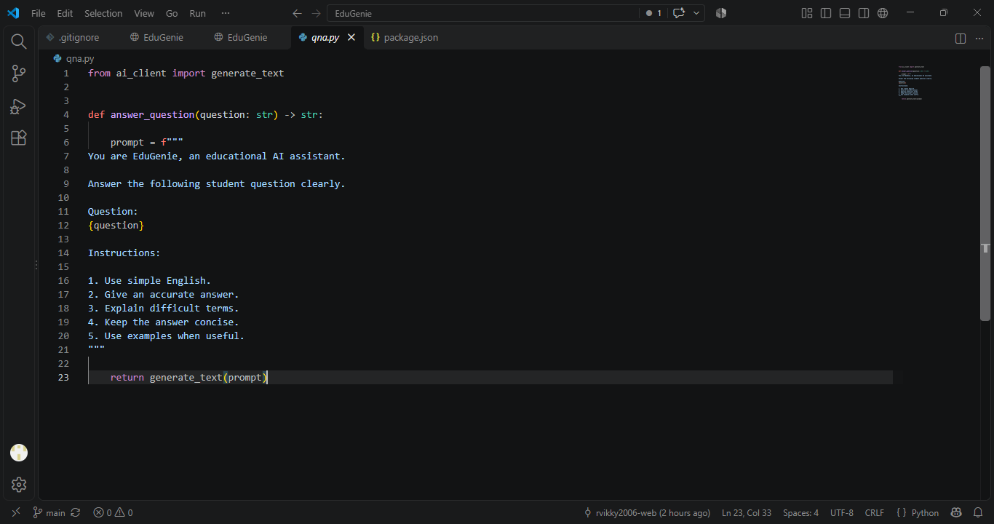

Fig. Q/A Module
- Quiz Module
EduGenie generates three multiple-choice questions (MCQs) from a given passage, each containing four carefully crafted options. It utilizes the Gemini model to comprehend the context and meaning of the passage, ensuring that the questions are relevant and the distractors are plausible. The final output is structured in JSON format for easy integration.
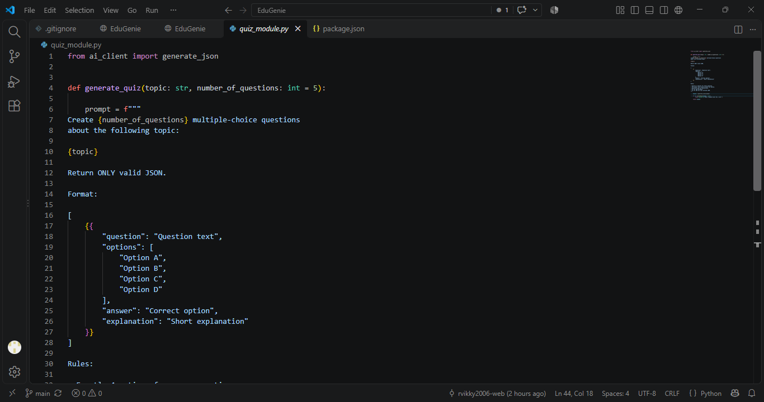

Fig. Quiz Module Logic
It sends a structured prompt to the model, expecting a valid JSON response with each question containing four options and a correct answer. To ensure proper parsing, it cleans any Markdown code blocks using the clean_json_blockfunction. The cleaned response is then parsed into a Python list. If an error occurs during generation or parsing, it returns a detailed error message for debugging.
- Summary Module
This feature leverages Gemini’s generative capabilities to summarize long paragraphs into concise, easy-to-understand versions, making it ideal for quick revision. It ensures the core information is retained while eliminating redundancy, helping learners absorb key points efficiently without losing clarity or context.
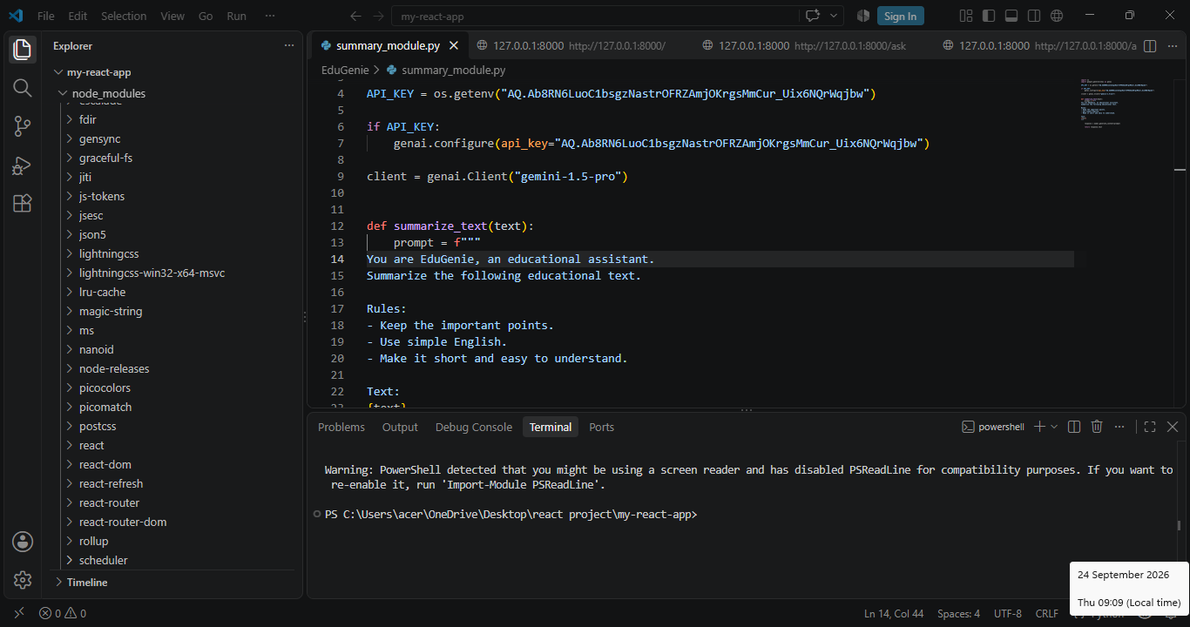

Fig. Summary Module

- Learning Path Module
The get_learning_recommendations function uses Google Gemini to generate a personalized, structured learning path for any given topic. By crafting a detailed prompt, it instructs the AI to suggest beginner to advanced concepts, organized by difficulty, and supported with useful resources such as videos, articles, or books. It ensures adaptability to the learner’s level. The function safely handles API responses and errors, providing either the generated text or a helpful error message if the response is invalid or incomplete.
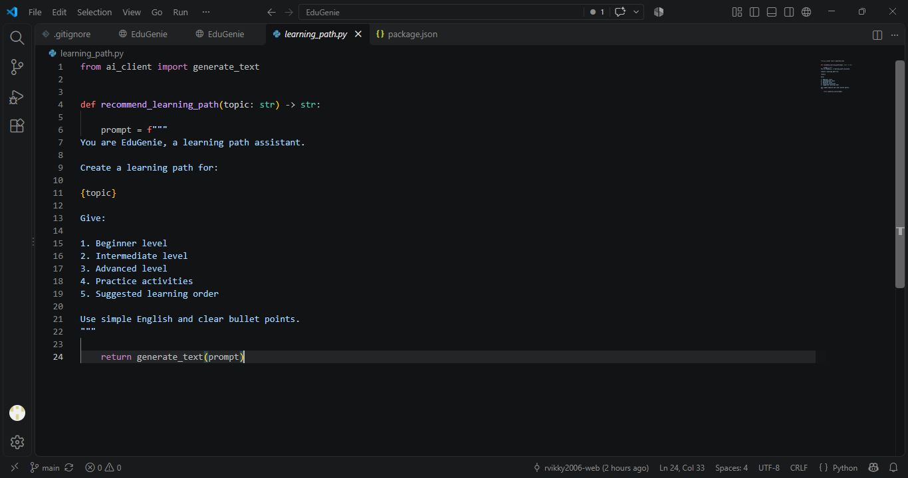

Fig. Learning Path Module

Activity 2.2 : Backend API with FastAPI
- Defined RESTful endpoints for each module:
  - /qa
  - /explain
  - /quiz
  - /summarize
  - /learn/recommendations
- Connected each endpoint to a respective module logic
- 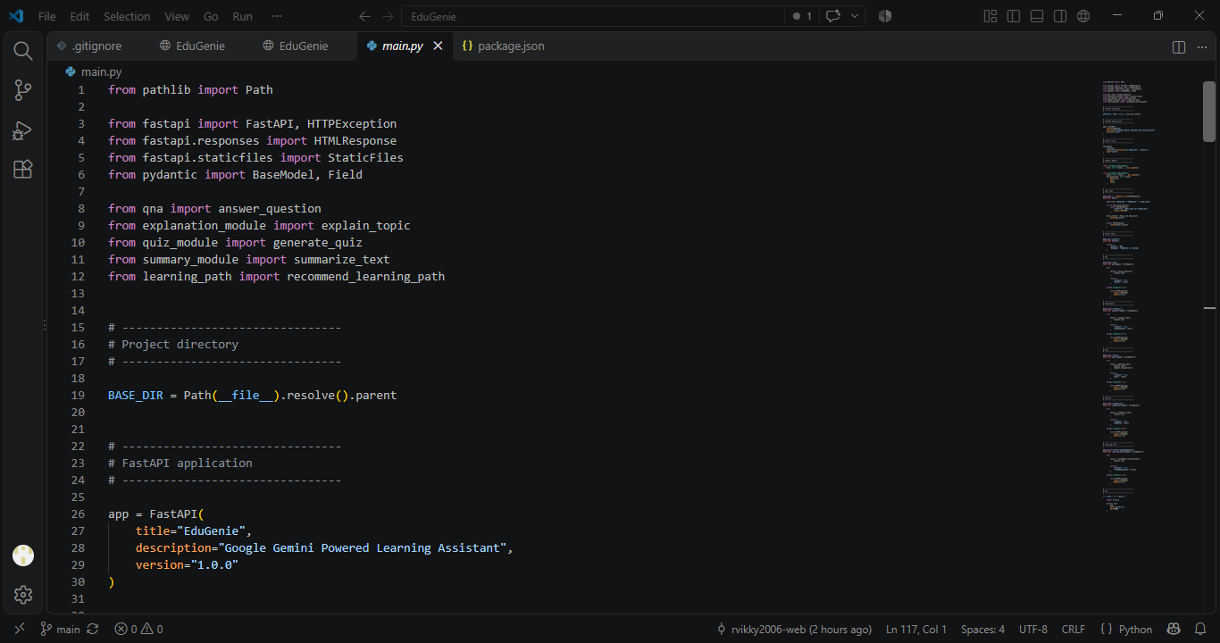
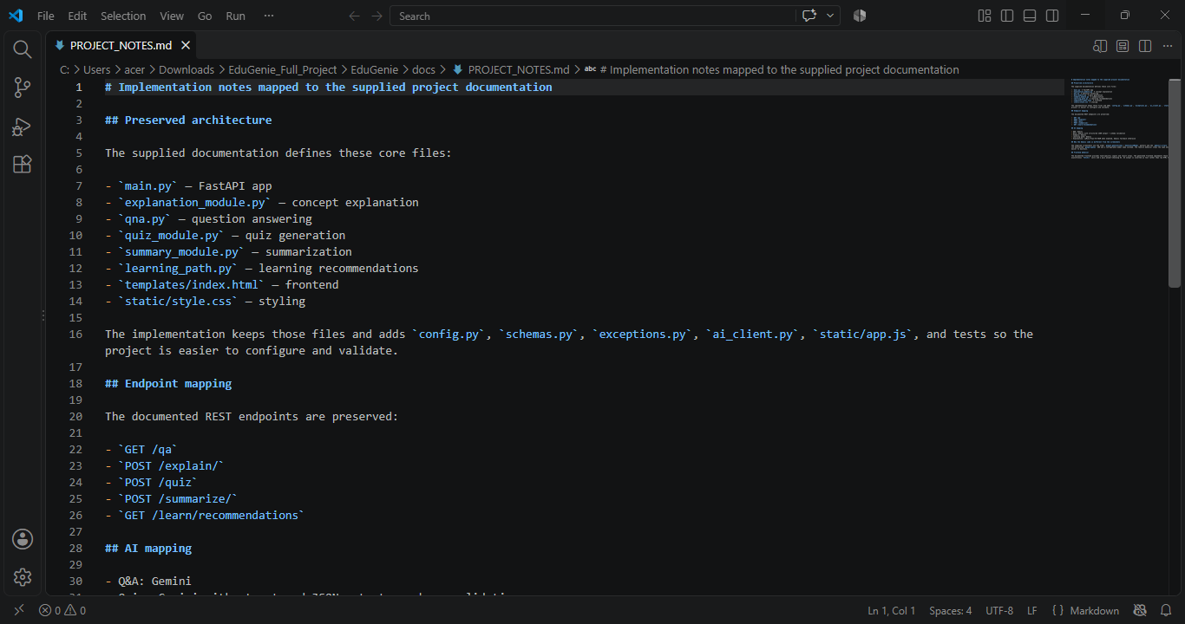

Fig. Endpoints of API
MILESTONE 3: Frontend Development
Activity 3.1: Build Web Interface
- HTML Form (index.html):
  - Task dropdown (Explain, QnA, Quiz, Summary, Recommend Path)
  - Text area for user input
  - Submit button
- CSS Styling (style.css):
  - Responsive design
  - Styled buttons, input areas, and result container
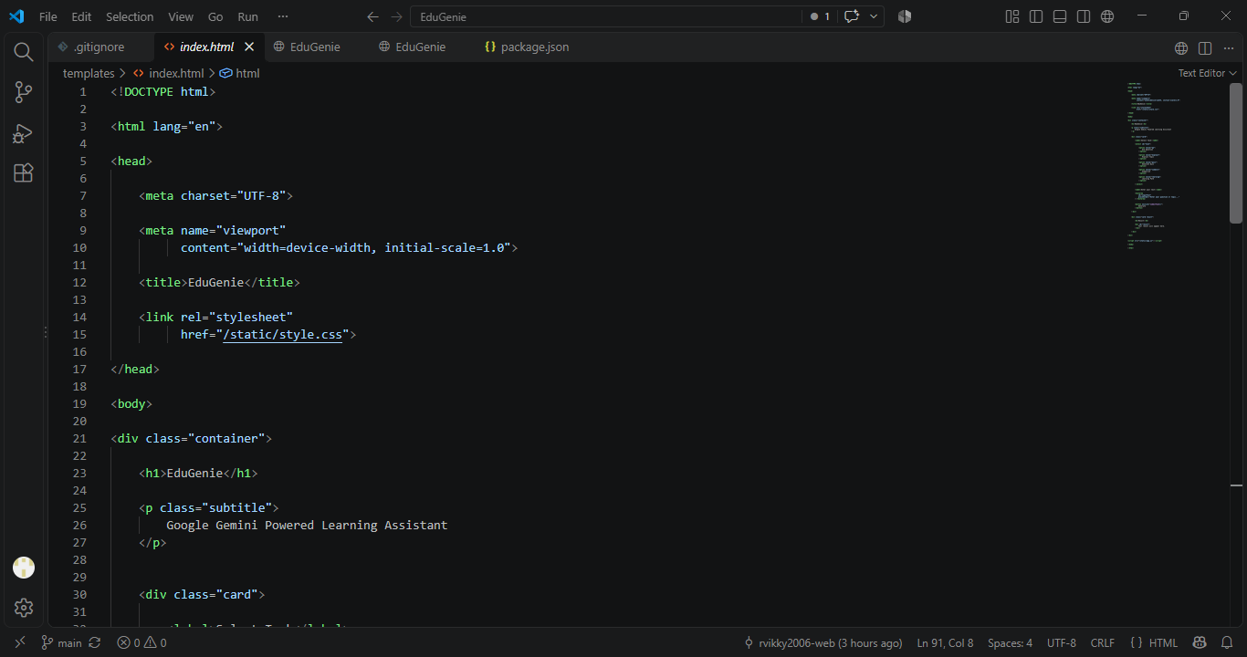

Fig. Showing Frontend Intergration
Activity 3.2: Live Integration
- Form submission sends POST request to FastAPI backend
- Result appears below input box in real-time

MILESTONE 4: Deployment
- Activity 4.1: Run Locally
Run locally with uvicorn main:app --reload
Navigate to: http://127.0.0.1:8000
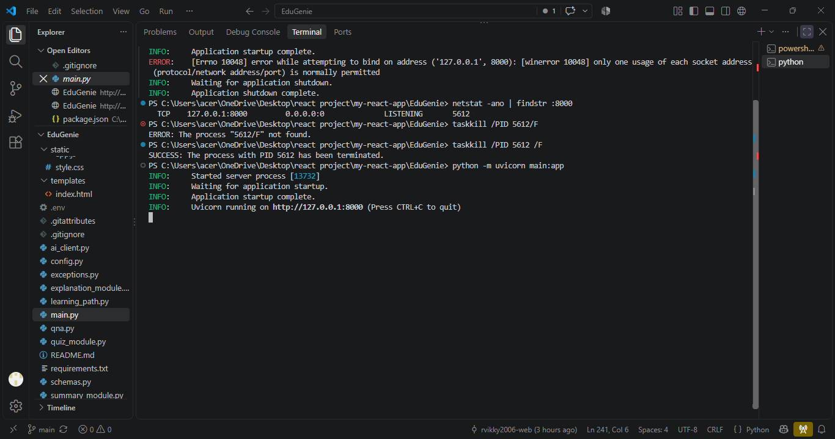

Fig. Showing the Application can be accessed
- Activity 4.2: Functional Testing
Ask a question
Get an explanation
Generate a quiz
Summarize content
Get a personalized learning plan

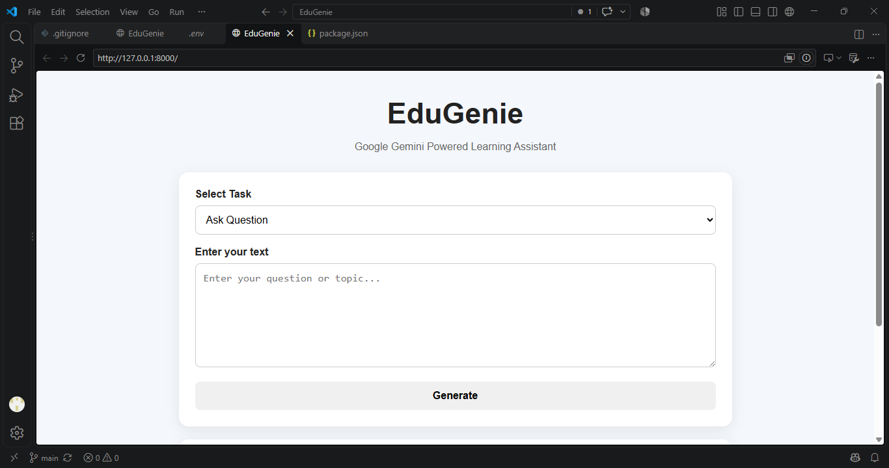

Fig. EDUGENIE
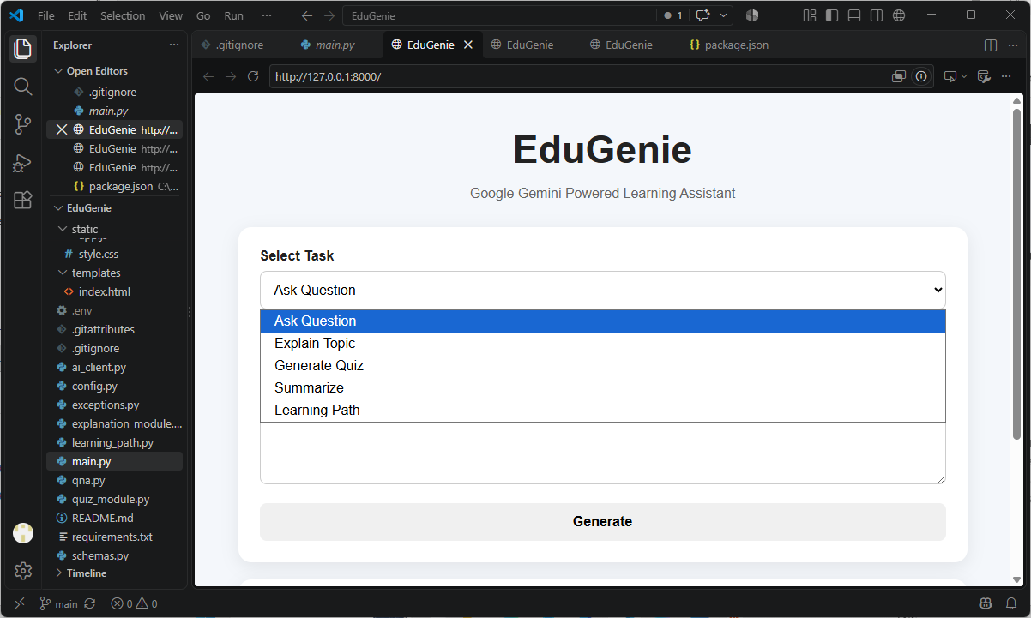

Fig. EDUGENIE

Exploring EduGenie:

a.Asking question:

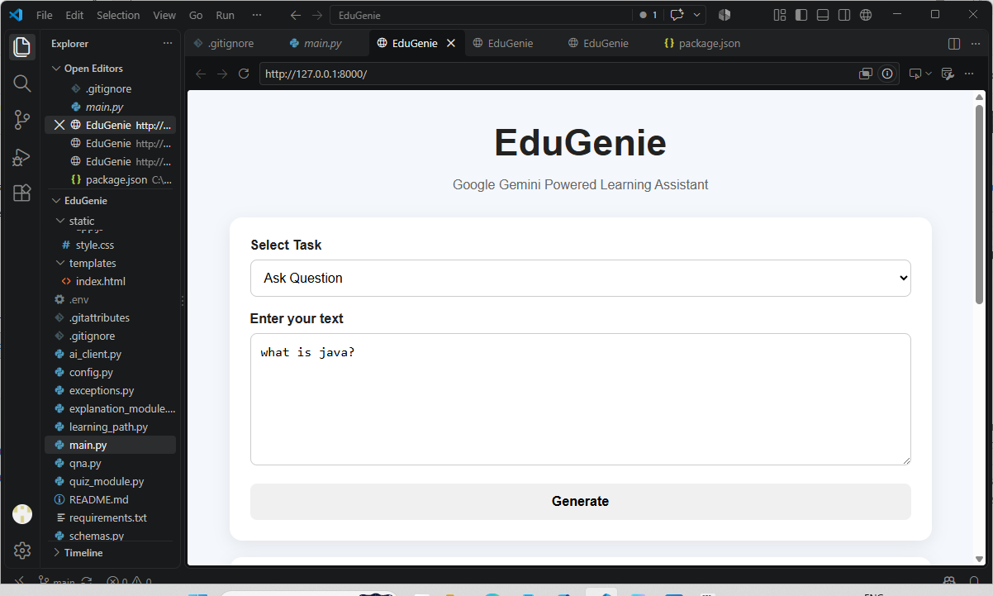
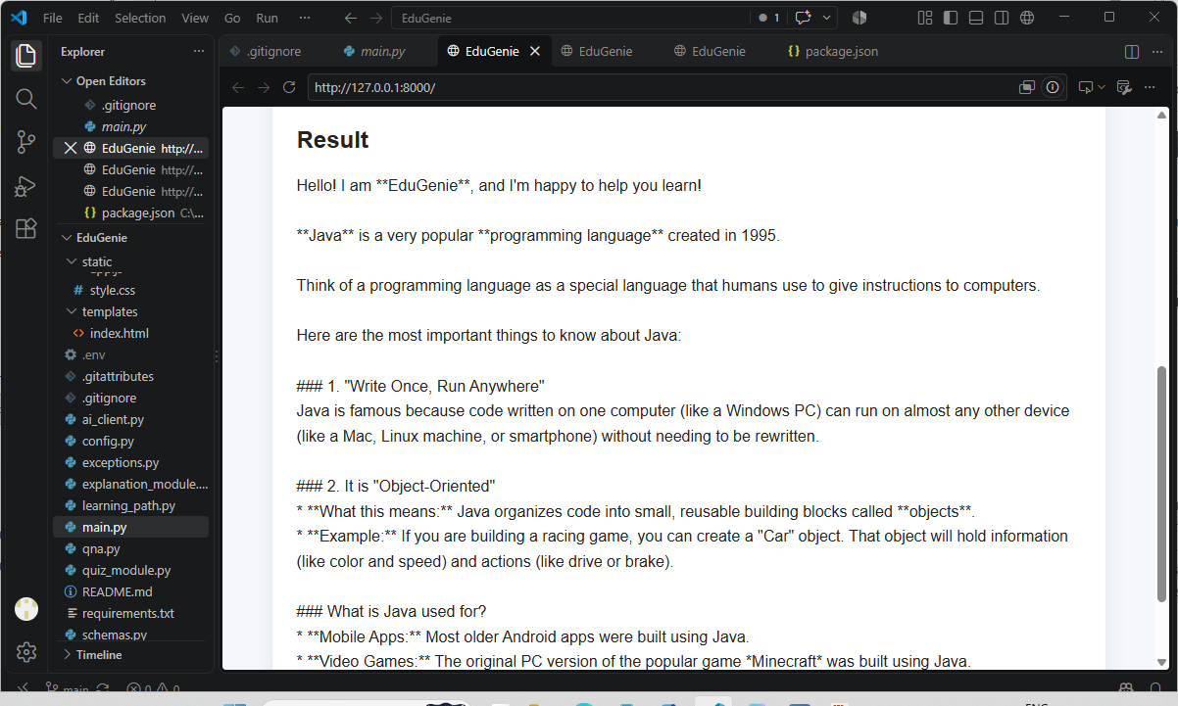

b.Explanation of any topic:

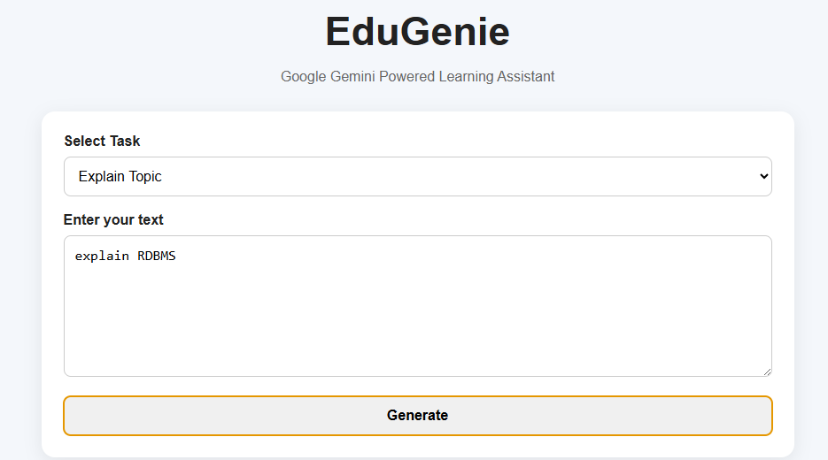
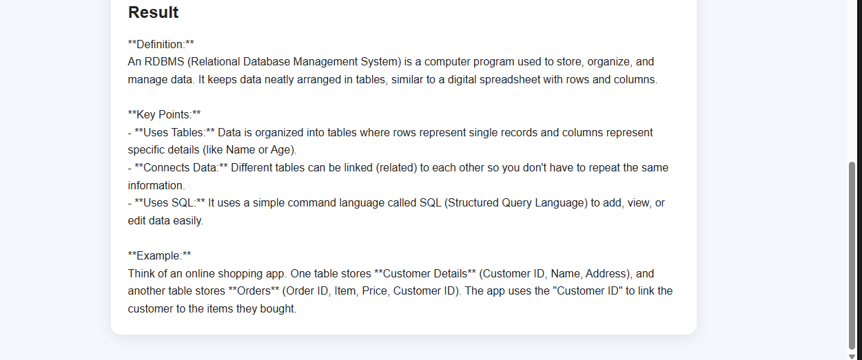
c. Summarising long paragraphs:
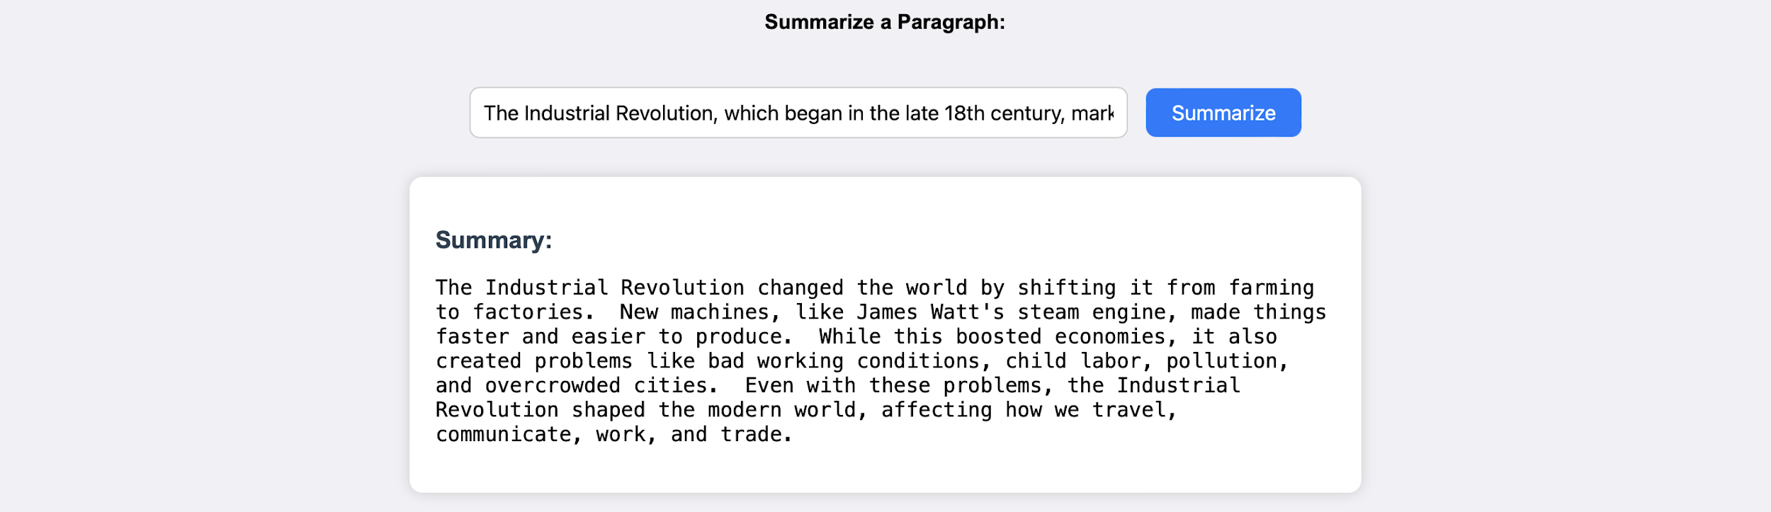

It generates three questions with 4 options each. It corrects the answer if chosen wrong.
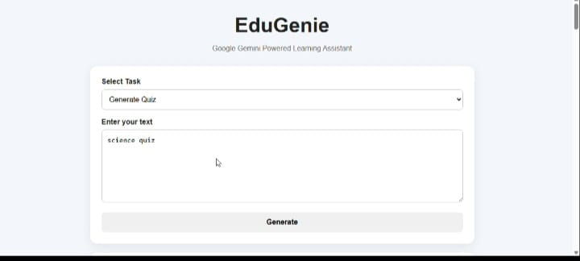

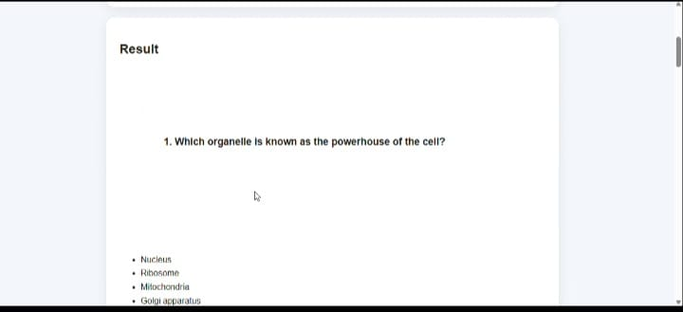
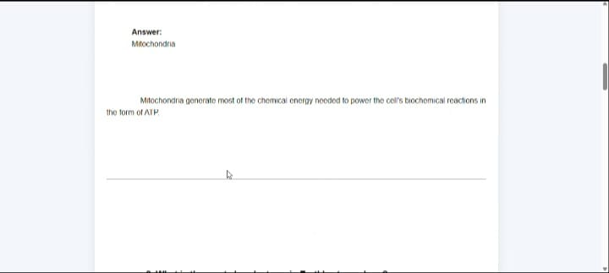Guiding with learning recommendations from beginners level to advanced level.

Conclusion:

EduGenie is an innovative AI-powered educational platform developed to make the learning process easier, faster, and more effective for students. The main purpose of EduGenie is to provide students with personalized learning support through the use of Generative AI. It can help students understand difficult topics, generate study materials, summarize important information, and provide quick answers to their academic questions.

The project combines modern web technologies with Artificial Intelligence to create an interactive and user-friendly learning environment. Instead of depending completely on traditional learning methods, students can use EduGenie as a digital learning assistant that is available whenever they need help. This makes the learning process more flexible and convenient.

EduGenie also demonstrates how Generative AI can be effectively used in the education field. It can reduce the time required to search for information and help students focus more on understanding concepts. The system can be further improved in the future by adding features such as voice-based learning, personalized study plans, quizzes, progress tracking, multilingual support, and advanced AI tutoring.

Overall, EduGenie provides a smart and modern approach to education by combining technology, Artificial Intelligence, and personalized learning. The project shows the potential of AI to support students and create a more engaging, accessible, and efficient learning experience.

Submitted by:
Vigneshwaran.R
Sanjay.s
Mahalingam.k
Bharani.o
Mentor:
Date: 25/09/2025

